Subject : Radio Systems

Title : Features and Technical

Aspects of Edge

Course : E&EE Final Year

By : David Clarke

Date : 23_03_2001

- Introduction

Cellular radio services have been extremely successful in providing untethered voice communications, wireless data services have captured only a limited market share so far. One obstacle for wireless data services is their limited peak bit rates. Existing wireless data rates, up to several tens of kb/s, may be over one order of magnitude short of what is required to make popular applications user-friendly. The GSM system is the most popular second-generation wireless system today. It employs TDMA technology to support mobile users in different environments. This system, initially standardized and deployed in Europe, is currently deployed worldwide. Each carrier is 200 kHz wide, which can support 8 simultaneous full-rate circuit voice users using 8 TDMA bearer slots. It also supports a circuit-data capability at 9.6 kb/s. To support higher data-rates, GPRS (General Packet Radio Service) employs variable-rate coding schemes and multi-slot operation to increase peak rates. Using packet access further enhances system throughput and spectrum efficiency. However, the peak-rate for GPRS is limited to about 100 kb/s, and even higher rates are desirable for providing popular Internet applications such as Web Browsing and email. The target rate for third-generation wireless services is 384 kb/s in macro-cellular environments. Therefore, ETSI has developed EDGE (Enhanced Data-Rates for GSM Evolution) technologies. This system employs adaptation between a number of modulation and coding schemes (“link adaptation”) as a means for providing several hundred kb/s peak rates in a macro-cellular environment while supporting adequate robustness for impaired channels.

In addition to GSM evolution, the TDMA community also adopted EDGE for high-speed data services in the third-generation, radio transmission technology proposal .Typically, current GSM service providers employ 3/9 or 4/12 reuse plans and they may not impose a different frequency reuse plan for EDGE, which is thus termed “EDGE Classic.” However, in North America, initial deployment using 1MHz in each direction is being considered due to limited spectrum and the potential need to re-deploy spectrum currently used for ANSI 136 systems. This implies very aggressive frequency reuse having a minimum of only three 200-kHz frequency carriers. This means allocating one frequency to each of the three sectors per base station and reusing the frequency set everywhere (“1/3 reuse”) and providing control signaling with extra reuse protection in the time domain, which is named “EDGE Compact” due to its compact spectrum requirement. In Section 2, we briefly describe the link adaptation and incremental redundancy techniques. Section 3 describes EDGE Compact and Classic systems and Section 4 outlines deployment scenarios for both cases, followed by downlink performance comparison in Section 5. Section 6 discusses some physical and MAC (Medium Access Control) layer enhancement techniques, which significantly improve the performance. Finally Section 7 concludes this paper.

- Modulation and Coding Adaptation

The basic concept of EDGE is to provide higher data rates per radio time slot than is possible with GMSK modulation. This allows the support of existing services with a lower number of time slots. In addition it allows the introduction of new services with up to 59.2 kb/s per timeslot or almost 480 kb/s per carrier in multi-slot operation, hence offering an evolution path for GSM to support multimedia applications.

  - Radio link formats

The EDGE concept can be seen as an extension of GPRS for packet service, which is called EGPRS. ETSI has combined EDGE with circuit switched data modes, and these modes are called ECSD. Efficient link adaptation is a key feature for EDGE and has been jointly developed with EDGE enhanced modulation. With a high degree of compatibility in the bandwidth and symbol rates with GSM, EDGE provides higher rates for users with good signal to interference plus noise ratios (SINR). This is achieved by employing
lower channel-coding redundancy and/or 8PSK, which carries 3 bits per symbol (as opposed to 1 bit per symbol achieved by GMSK). Table 1 shows the bit rate provided by different MCS (Modulation and Coding Scheme) modes. An EGPRS capable terminal will have 9 modulation and coding schemes available compared to 4 for GPRS.

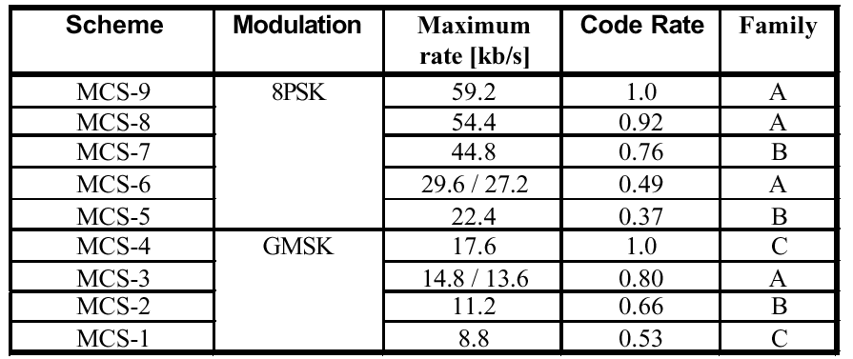

Table 1. Overview of packet data services for EDGE

  - Radio link control

Radio link control selects among the MCS options, in response to SINR or equivalent quality measures. Link adaptation explicitly changes MCS modes based on link quality estimates, and is also called mode selection.
Hybrid ARQ transmits additional redundancy bits after errors are observed. It is made possible by sending the packets with different puncturing patterns from the same mother code during retransmission. This allows data transmission to begin with low redundancy and increases redundancy only when errors occur, thus adaptively changing the effective date rates.

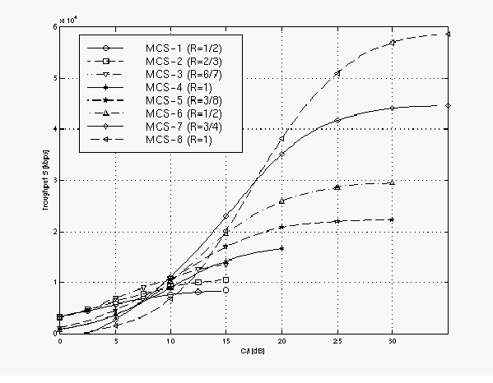

Figure 1. Throughput as a function of SIR for different transmission modes 1

The criterion for selecting a particular data-rate as proposed in [2] is to conceptually maximize throughput defined as

S = R_{c}(1 – BLER_{c})

where R_{c} and BLER_{c} are the data-rate and BLER (“Block Error Rate,” where a “block” is the RLC (radio link control) block.) for the transmission mode chosen. Figure 1 shows the throughput as a function of SIR for different modes. It is found that this threshold criterion is generally effective in achieving a high aggregate system throughput, but the QoS (Quality of Service) for individual users can be degraded as system load increases. Furthermore, link adaptation requires the receiver to continuously perform quality measurements and provide timely feedback to the transmitter, so typical operation may be with somewhat higher thresholds.

- EDGE Compact and EDGE Classic

GSM systems are usually planned on the basis of 4/12 (4 base stations, 3 sectors each, per cluster) or 3/9 frequency arrangements. The carriers that contain broadcast control channels (BCCH carriers) are required to transmit continuously and without hopping on control time slots to facilitate handoff measurements, control channel acquisition, and so on. These carriers usually are arranged in a 4/12 reuse pattern. Traffic channels can frequency-hop and, on non-BCCH carriers, they can use discontinuous transmission (based
on voice-activity detection), and if so, typically are arranged in a 3/9 reuse pattern. These arrangements provide the strong SIR protection typically required for delay-intolerant voice services and non-acknowledged
control channels. EDGE “Classic” is defined to be a system using continuous BCCH carriers that are typically in a 4/12 or 3/9 reuse pattern and which requires at least 2.4 MHz bandwidth in each direction. Additional traffic carriers, if available with higher total bandwidth, can be deployed under a lower reuse factor.

Some system operators, particularly those in North American where 3G spectrum has been partially allocated for PCS, have to re-allocate in-service spectrum to deploy EDGE. In that case, EDGE Compact may be used
for initial deployment using as little as 1 MHz in each direction allowing only three 200-KHz frequency carriers. This means allocating one frequency to each of the three sectors per base station, and the frequency set is reused at every base station (“1/3 reuse” for EDGE “Compact” mode). While good spectrum efficiency is achieved, the provisioning of common control functionality, such as system broadcast information, paging, packet access and packet grant, cannot be deployed with 1/3 reuse. 4/12 or 3/9 reuse is
required for reliable control channels. In order to achieve adequate co-channel reuse protection for the control channels, reuse in the time domain is exploited, which requires frame synchronization of base stations. Figure 2 shows an example with 4 timing groups in addition to 1/3 frequency reuse to obtain 4/12 reuse for the control channels.

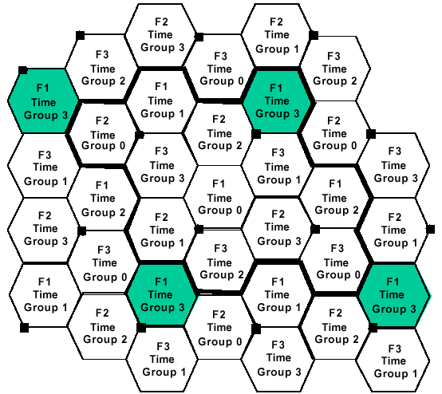

Figure 2. Example cell pattern for a 4/12 time and frequency reuse

EDGE Compact uses discontinuous transmission based on a 52 -multiframe2
(a multi-frame consisting of 52 frames) and designates different time slots and frames for sending control information. In blocks (blocks are non-overlapping and are each comprised of timeslots from the same timeslot number of 4 successive frames) when a sector belonging to one of the time-groups transmits or receives common control signaling (serving time-group), the sectors belonging to other (non-serving time-groups) are idle. This creates an effective reuse of 3/9 or 4/12, which is necessary for control signaling, while allowing 1/3 reuse for the traffic channels. Specifically, slots 1, 3, 5 and 7 are used for timing groups 0, 1, 2 and 3, respectively, to send common control information on frames 0-3, 21-24, 34-37 and 47-50. Frames 12, 25, 38 and 51 are also not allowed for traffic as they are reserved as idle frames or to send timing advance, frequency correction or synchronization information. More frames can be allocated for control signaling as needed. Therefore, up to
32 frames or 8 blocks per 52 multi-frame can be allocated for traffic channels on the designated control slots. This is 2/3 that of a regular slot capacity in which 48 frames in a 52 multi-frame are used for traffic in a given non-BCCH slot. When using 3 time-groups (i.e., effectively 3/9 reuse), one of the 4 time-groups is unused and it is instead used as a traffic channel.
Figure 3 shows the control channel BLER distribution for both 3/9- and 4/12-reuse based systems. For about 90% of the cases, the BLER is better than 4% and 15% for 4/12 and 3/9 reuse, respectively, corresponding to the overall average BLER of about 2.4% and 5.2 % (not shown in the figure), respectively. The performance of the 3/9-reuse system may not be reliable enough at the tail end of the distribution. However, since the traffic channel performance is highly correlated with that of the control channel, i.e., a
mobile station with poor control channel BLER most likely cannot support reliable traffic performance, the tail end performance may not be very crucial. The control channel performance for EDGE Classic is expected to be similar because the same reuse factor is employed for the control channel.

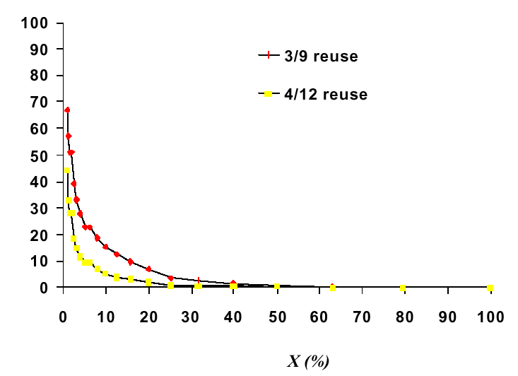
Figure 3. Distribution of BLER for control channels

- Deployment Scenarios

The minimum spectrum required for Compact deployment is 600 kHz and that for Classic is 2.4 MHz (neglecting guard bands in both cases). Therefore, at 2.4 MHz and above, there exists the option of either Compact or Classic deployment. The choice of system is partly dependent on the performance of the systems. The performance in turn is dependent on the reuse configuration employed in the deployment. For the purposes of this study and to enable valid comparisons, the reuse configurations are such that control channels are always at 4/12 reuse while traffic channels are at 1/3 reuse whenever possible. The exceptions are the traffic channels of a Classic control (BCCH) carrier, which are at 4/12 reuse. We also consider the same control-channel capacity (one active slot of a carrier) for both cases under all scenarios. Table 2 and the text following describe the scenarios considered:

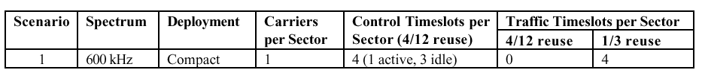
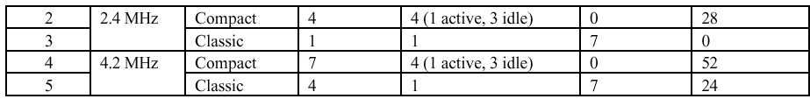
Table 2. Deployment Scenarios

a) 600 kHz deployment
i. Compact (Scenario 1)
There are three 200 kHz carriers, one per sector of a tri-sectored base station. A carrier in a given sector can use the even-numbered slots and the unused portion of the odd-numbered control slots for traffic in a 1/3 reuse. Here, we do not consider the unused portion of the odd-numbered control slots.

b) 2.4 MHz deployment
i. Compact (Scenario 2)
There are twelve 200 kHz carriers. Three of the carriers are deployed in a configuration identical to that of the 600 kHz deployment. The remaining nine carriers are dedicated to traffic and deployed in a 1/3 reuse configuration. Therefore, any given sector of a tri-sectored base station has four carriers, three of which have eight traffic slots each and the fourth has four traffic slots, all in a 1/3 reuse pattern.
ii. Classic (Scenario 3)
There are twelve 200 kHz carriers, all continuous control carriers with one allocated per sector of a tri-sectored base station. Therefore, a given sector has one carrier of which one slot is dedicated for control and seven slots are dedicated for traffic. All control and traffic slots are in a 4/12 reuse configuration.

c) 4.2 MHz deployment
i. Compact (Scenario 4)
There are twenty-one 200 kHz carriers. Three of the carriers are deployed in a configuration identical to that of the 600 kHz deployment. The remaining eighteen carriers are dedicated to traffic and deployed in a 1/3 reuse configuration. Therefore any given sector of a tri-sectored base station has seven carriers, six of which have eight traffic slots each and the seventh has
four traffic slots, all in a 1/3 reuse pattern.
ii. Classic (Scenario 5)
There are twenty-one 200 kHz carriers, twelve of which are in a 4/12 reuse pattern and the remaining nine in a 1/3 reuse pattern. Therefore, a given sector of a tri-sectored base station has four carriers. One of these is the continuous control carrier and it has seven slots dedicated for traffic in a 4/12 reuse pattern. The other three carriers have a total of twenty-four slots in a 1/3 reuse pattern.

- Performance Comparison

Figures 4 and 5 show the average user-packet delay as the throughput per base station (in three sectors) increases for the 2.4 MHz and 4.2 MHz scenarios, respectively. Here we can clearly see the trade-off between QoS, as determined by the delay experienced by the web-browsing users, and the system capacity, as indicated by the total throughput that a typical base station can deliver to all users who are sharing the radio resources.

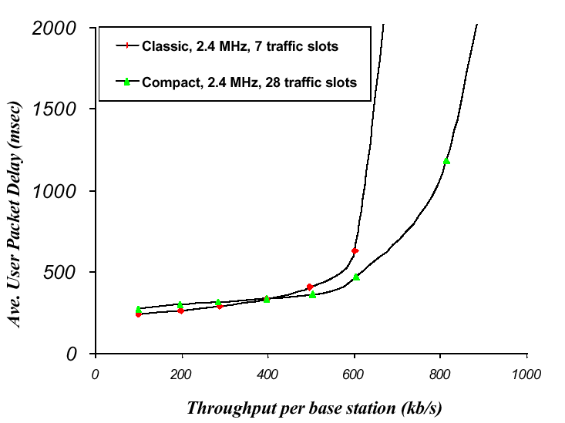

Figure 4. Comparison of Classic and Compact performance for the 2.4 MHz scenarios

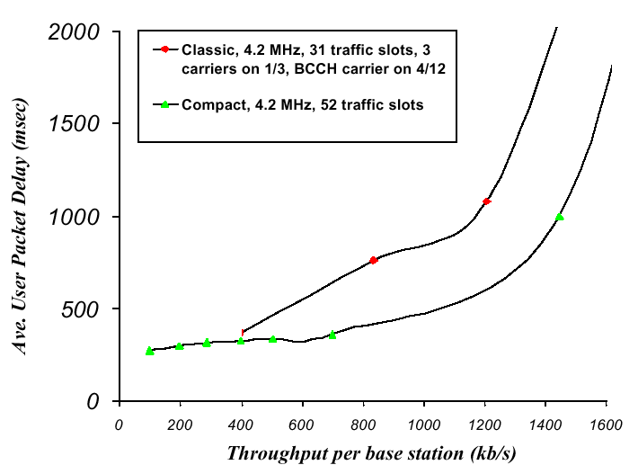

Figure 5. Comparison of Classic and Compact performance for the 4.2 MHz scenarios

- Performance Enhancements

In this section we outline several enhancement techniques. All of these techniques can be implemented in the physical and MAC layers with little or no impact on standards. All the performance results shown below assume EDGE with one carrier per sector. Control channels are not explicitly simulated, so we assume 8 traffic slots are available per carrier. In addition, we consider 600 kHz total bandwidth in Figures 6-8 and 2.4 MHz in Figure 9. Furthermore, the radio link performance was based on an earlier proposal with rate-adaptation among QPSK/16QAM modes,[2] which were 15%-20% higher in the bit rates. However, the general performance trends for GMSM/8PSK mode adaptation are similar.

  - Simple diversity or interference suppression at terminals and smart antennas at base stations

These are techniques that can be implemented in the physical layer. Simple diversity selects the better one between two diversity branches available at a mobile terminal. Interference suppression uses the MMSE (Minimum Mean Square Error) algorithm to further suppress co-channel interference at a two-branch diversity receiver. Smart antennas are implemented by forming four fixed beams on the downlink, with the beam that provides the strongest signal to serve a given terminal. In Figure 6, the left curves show the improvement experienced by a user, in terms of the throughput at a moderate load, by using these methods, while the right curves indicate system capacity enhancement as traffic load increases. Clearly, all these methods are effective in improving user experience as well as system capacity.

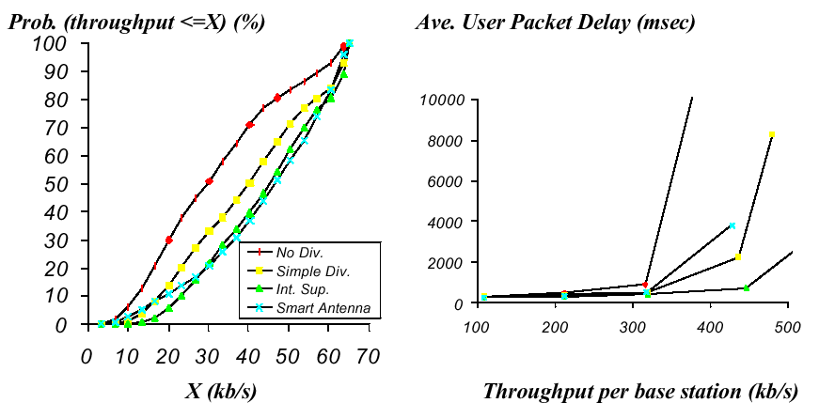

Figure 6. Performance improvement by diversity, interference suppression and smart antennas

Note that with aggressive frequency reuse, EDGE Compact achieves higher efficiency due to additional traffic capacity that can be provided for the same bandwidth compared to EDGE Classic. It is therefore a viable option not only for initial deployment but also for a system with higher available bandwidth. However, the requirement of synchronized base stations and other related issues must be carefully addressed in practical deployment.

  - Improved resource assignment

All the results shown so far are obtained based on random slot assignment as demand arrives. Several possible enhancements in the MAC layer can be introduced, ranging from simple, autonomous processes performed at individual base stations to those involving more sophisticated coordination among base stations. The details can be found in several papers. [8,9,10]
The key enabler of intelligent resource assignment is signal quality measurements, which are inherently required to perform link adaptation. Here we show two examples: (1) Mode-0 and (2) LI-DPA. Mode-0 is an additional MCS mode for which no transmission is allowed if the signal quality is below a threshold. Using mode-0, transmissions that are likely to fail are eliminated; this reduces interference without causing reduction of total system throughput. In fact, since the radio resources are made available to users who are likely to succeed, system throughput is increased. Figure 7 shows the improvement provided by this method. LI-DPA, least interference dynamic packet assignment, selects the time slot with the lowest interference to deliver the packets. Figure 8, showing the message delay which is greater than what 90% of the users experience as the throughput per slot increases, clearly indicates that there is significant improvement that can be achieved by this method; a combination of LI-DPA with mode-0 can further enhance performance.

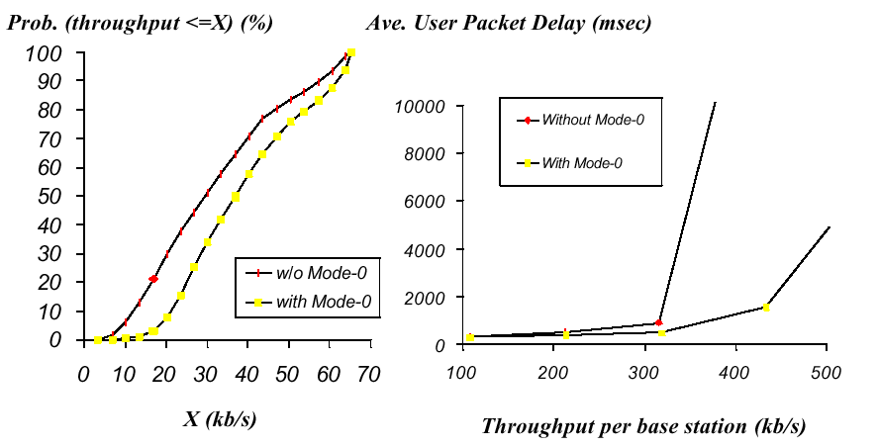

Figure 7. Performance improvement by the mode-0 method

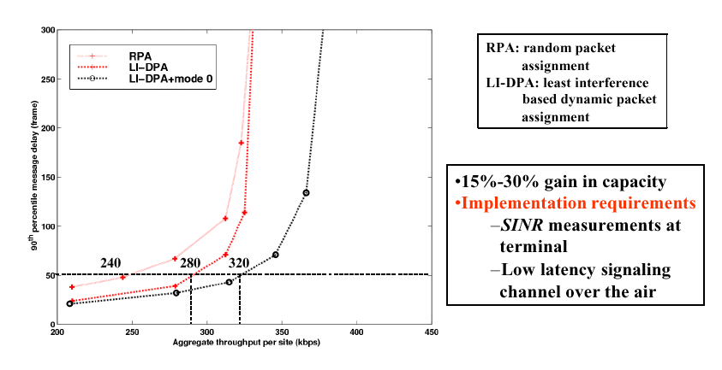

Figure 8. Performance improvement by LI-DPA and its combination with Mode-0

  - Multi-slot operation

Finally, improvement for individual users can be achieved by using multi-slot terminals. To show this, we use a concept: ECR (Equivalent Circuit Rate), which is the rate of a dedicated circuit connection required by our typical Web user in order to achieve the same level of user performance, which is
characterized by the mean Web page delay (download time.) The delay considered here for EDGE includes (1) delay due to traffic resource sharing among multiple users executing TCP/IP protocols (which was not considered in Figures 6 to 8) and (2) delay due to frequency reuse among multiple base stations. Figure 9 shows the results for 1-, 2-, 4- and 8-slot operation among
all terminals as traffic increases. We found that multi-slot operation enhances user experience the most for lightly loaded traffic levels, while the advantage decreases as load increases; virtually no gain can be achieved for a highly loaded system.

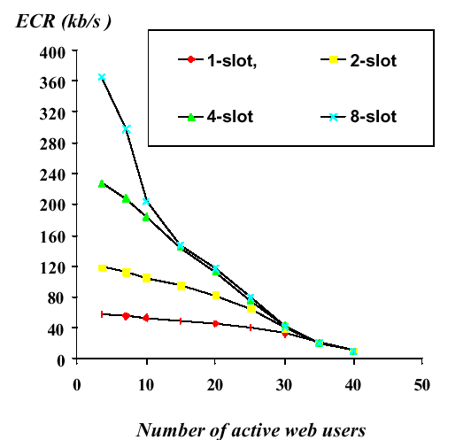

Figure 9. Performance improvement by multi-slot operation

- Conclusions

EDGE employs link adaptation and incremental redundancy to provide up to 480 kb/s data rates for each 200 kHz GSM-compatible radio carrier. EDGE Compact requires only three carriers reused every base station or one carrier for each of three sectors (1/3 reuse), enabling earlier deployment using less than 1 MHz of spectrum in each direction. With frame synchronization of base stations, EDGE Compact allows sufficient protection of common control signals. On the other hand, with a minimum of twelve carriers, EDGE Classic
deployment using 4/12 reuse pattern and continuous transmission of the BCCH carriers fully protects control channels without requiring base station synchronization, while permitting flexible reuse of non-BCCH carriers. With these two deployment options, extremely efficient utilization of scarce spectrum is possible for 3G wireless data services, and a graceful evolution from 2G is feasible. We discussed EDGE Compact and Classic scenarios and their performance. It was found that EDGE Compact has the potential to achieve better efficiency in addition to its advantages in initial deployments.
We also highlighted key enhancement techniques that can be implemented with little or no standard implications. In particular, several techniques exploiting diversity antennas can be implemented in the physical layer to provide significant improvement. Better radio resource management utilizing measurements to decide when not to transmit or to transmit signals using better time slots can be realized in the MAC layer for increased spectrum efficiency. Finally, multi-slot operation can enhance user peak-rates to provide
Internet experiences exceeding today’s wireline services.

- References

- J. Cai and D. J. Goodman, “General Packet Radio Service in GSM,” IEEE Communications Magazine, October 1997, pp.122-131.

- ETSI Tdoc SMG2 1015/97, “EDGE Feasibility Study, Work Item 184; Improved Data Rates through Optimised Modulation”, version 1.0, December 1997.

- P. Schramm, H. Andreasson, C. Edholm, N. Edvardsson, M. Höök, S. Javerbring, F. Muller and J. Sköld, “Radio Interface Performance of EDGE, a Proposal for Enhanced Data Rates in Existing Digital Cellular Systems,” Proceedings, VTC’98, pp. 1064-1068, May 1998.

